INSTALLATION OF VS CODE

Name: Sreejita Bhardwaj

PRN: 23070123130

Branch/Batch: EnTC B2

Experiment 1(a)

Steps to install and download vs code

1. Go to chrome and search for vs code installation (https://code.visualstudio.com/docs/?dv=win64user)

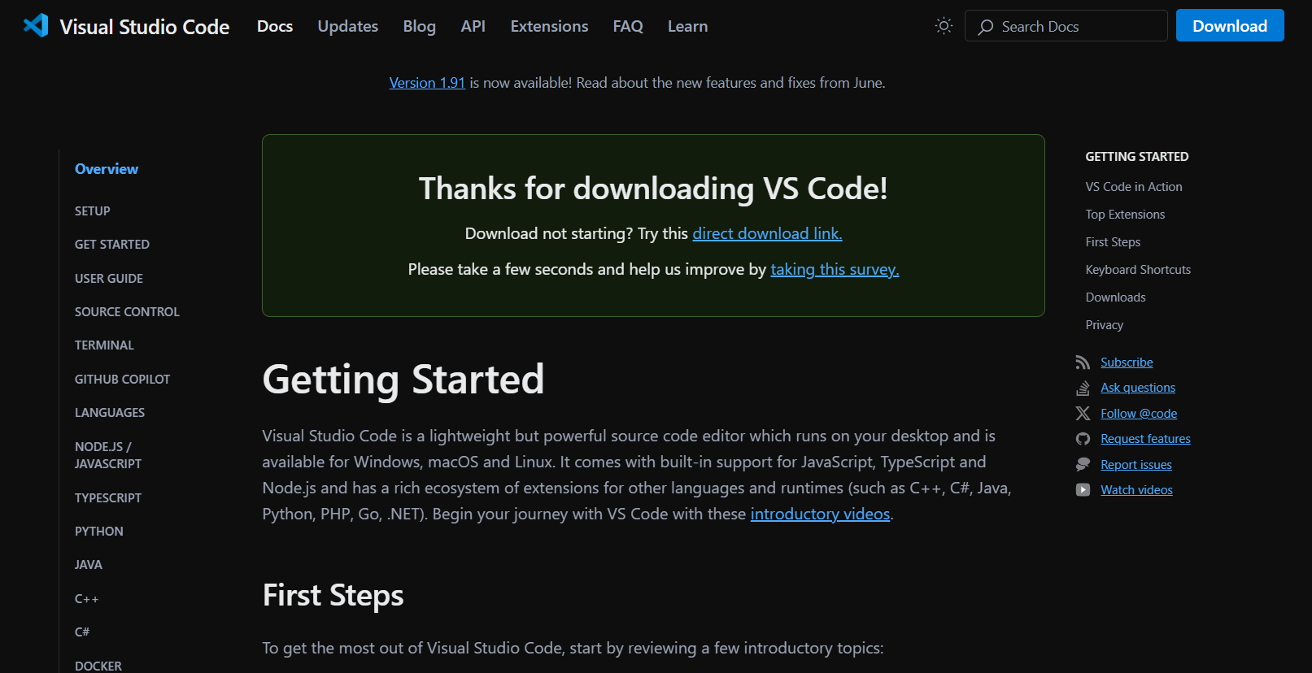

1. Now a pop up window will appear after you go to downloads. Click on I accept the agreement and then click on Next.

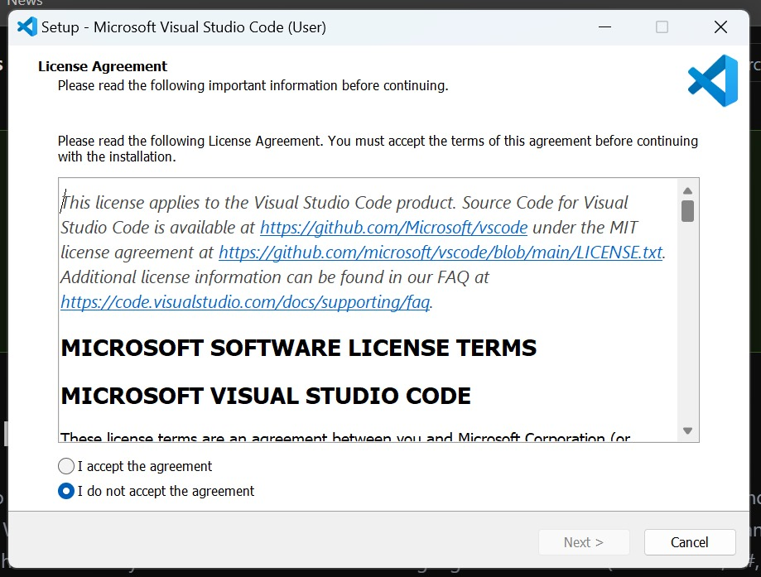

1. Vs code will install

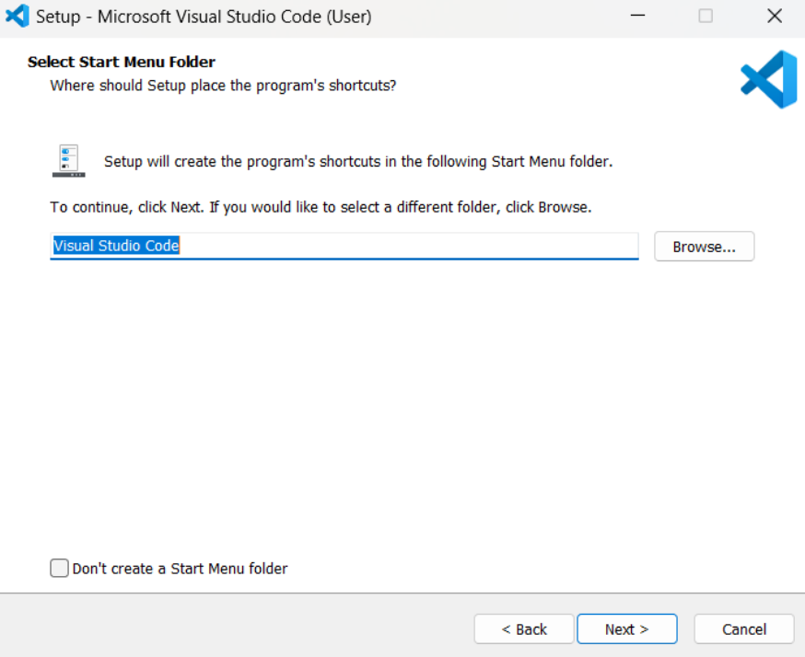

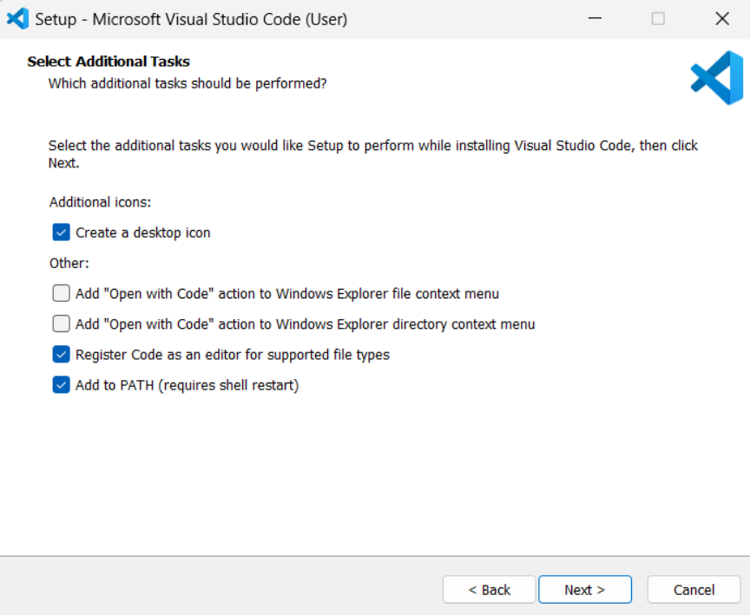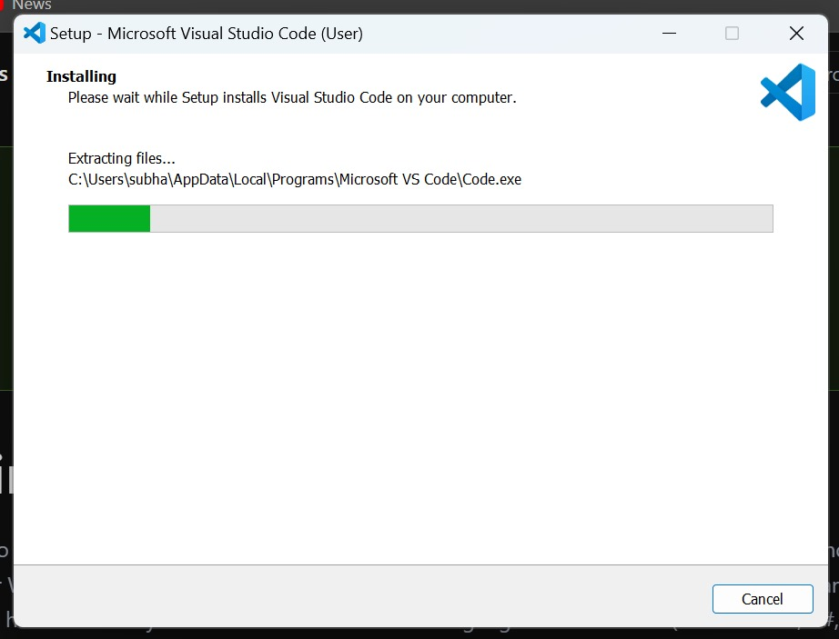

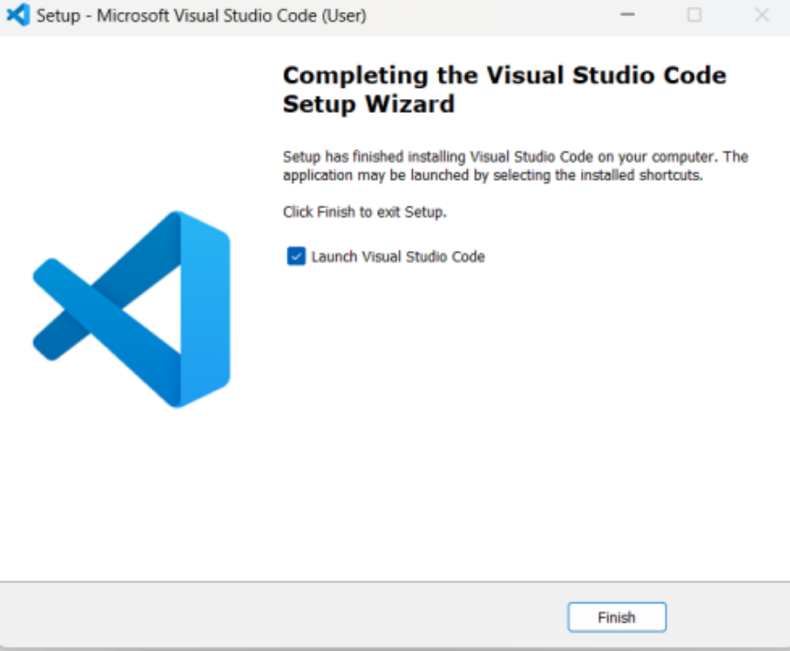

1. MinGW is to be downloaded because it is a complier

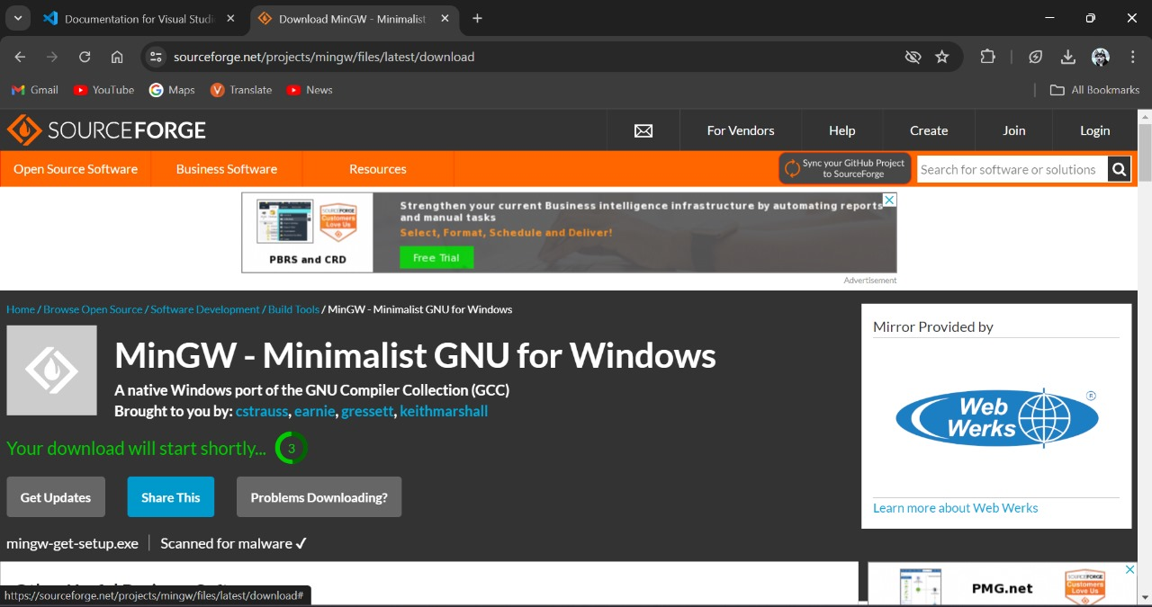

1. A pop up window will appear. Click on Install.

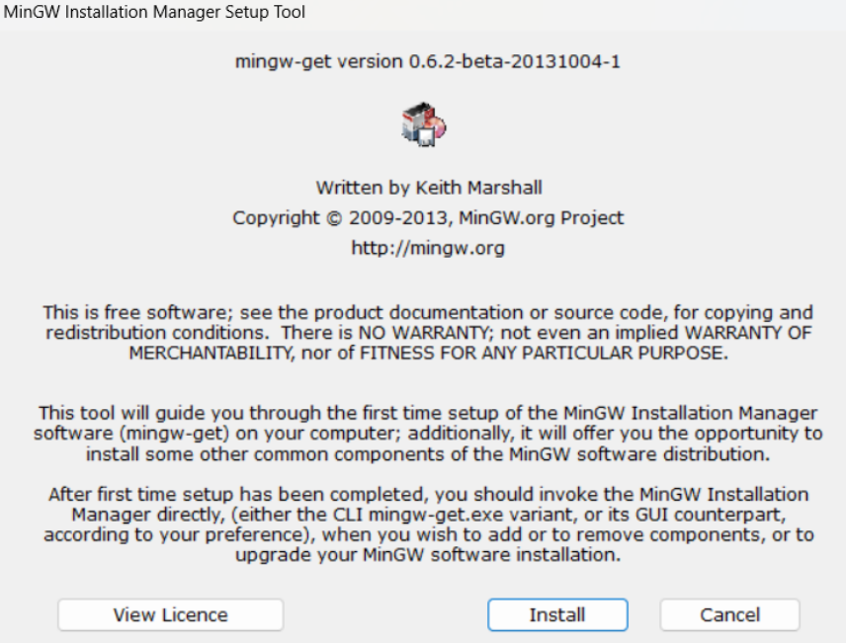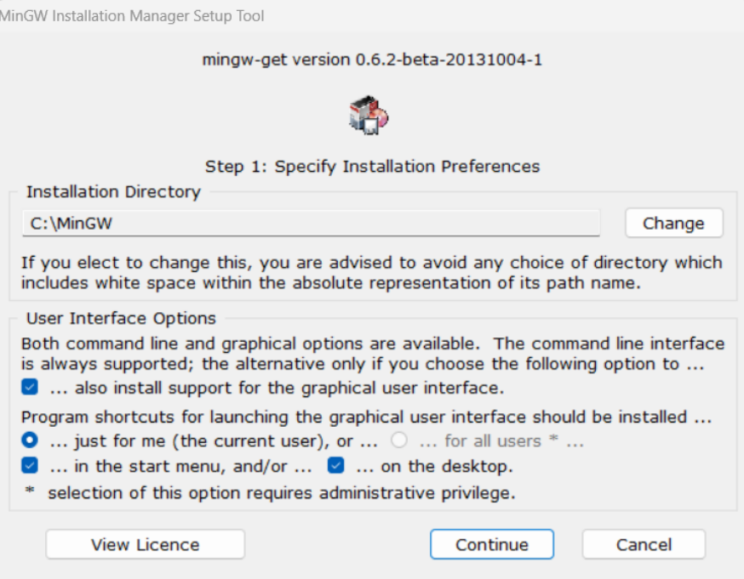

1. check all the required boxes for the C and C++ languages and click on Apply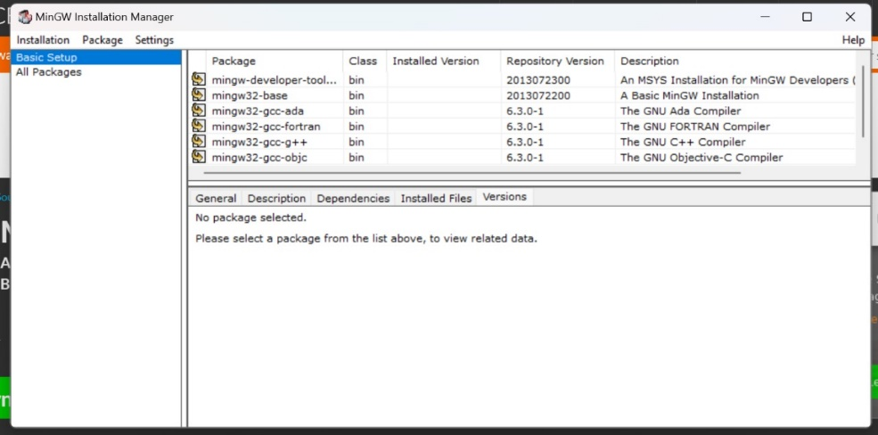
2. Now go to This PC, open MinGW folder, click on bin folder, a number of files will appear, Now copy its path.

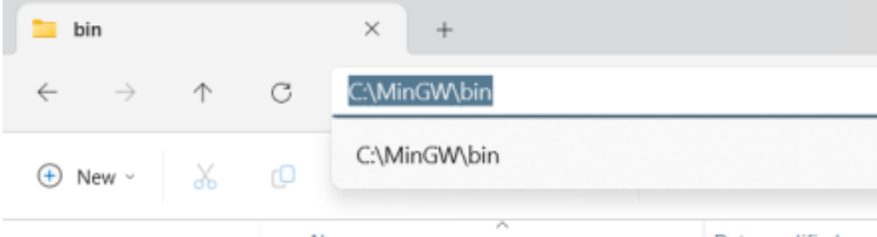

1. This PC, click on Advanced system settings, A pop up window will appear, click on Environmental variables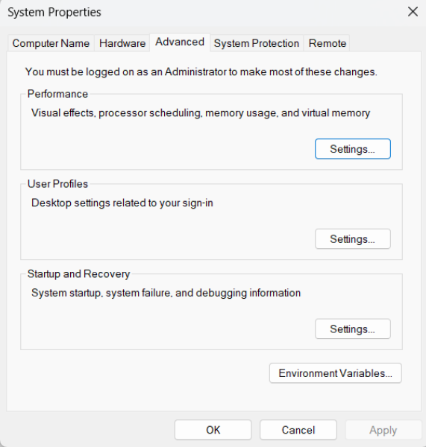

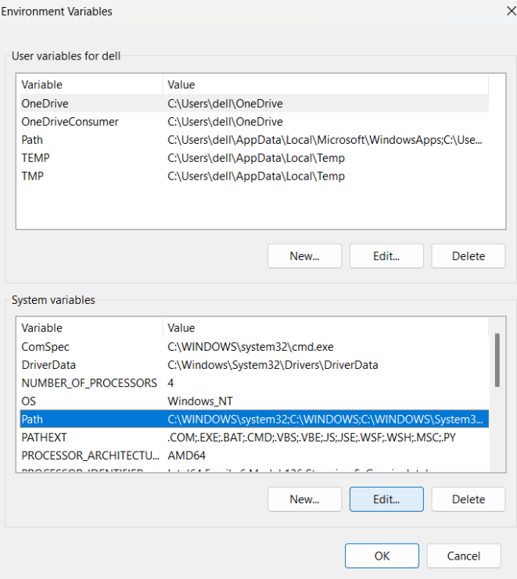

1. Click on New. Then paste the copied path. Then click on OK.

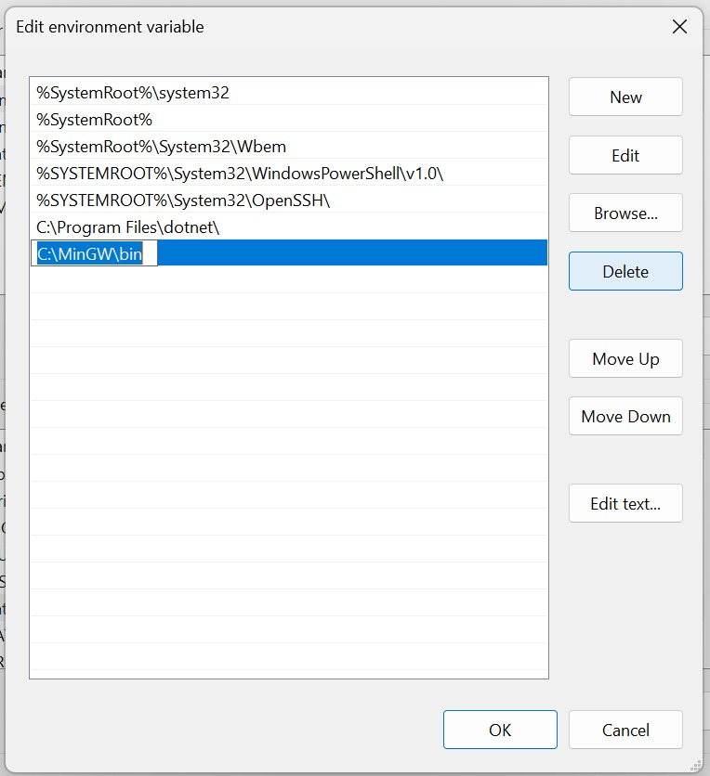

1. All changea are applied and you can use MinGW

